**WEEK1:**

1. Downloading and Installing Python and Modules

a) Python 3 on Linux

Follow the instructions given in the URL https://docs.python

guide.org/starting/install3/linux/

**Beginning Python installation**

For almost every Linux system, the following command could be used to install Python directly:

$ sudo apt-get install python3.8

***Getting Started***

We will start our installation by writing the password as mentioned in the below picture that gives the permission to perform further operations.

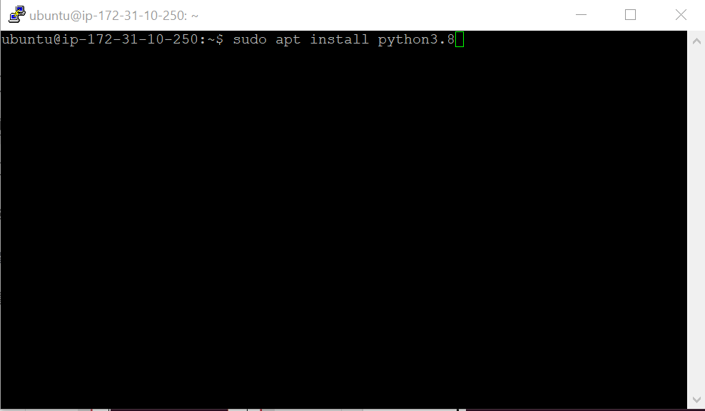

***Assigning DiskSpace***

Generally, it asks for additional diskspace and we generally continue by typing Y and then enter.

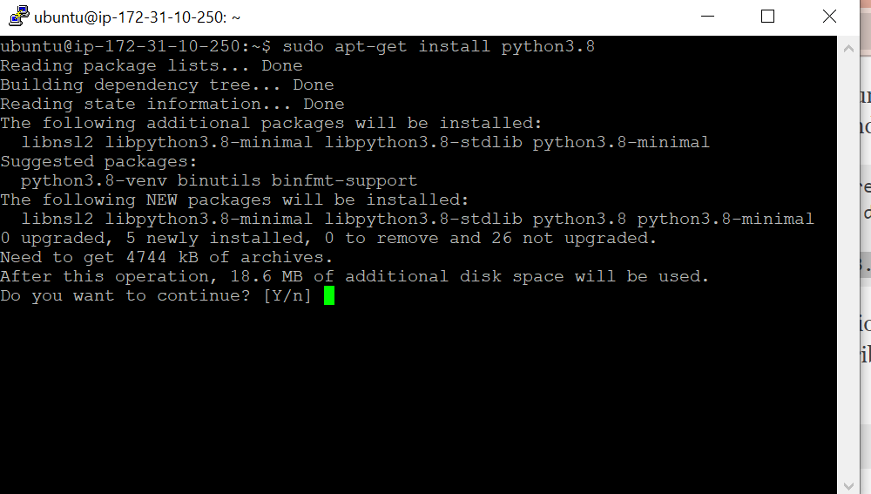

***Fetching and Installing Packages***

It’s a process in which required packages and modules are fetched and installed automatically.

It happens on it’s own when we give the permission to assign the diskspace.

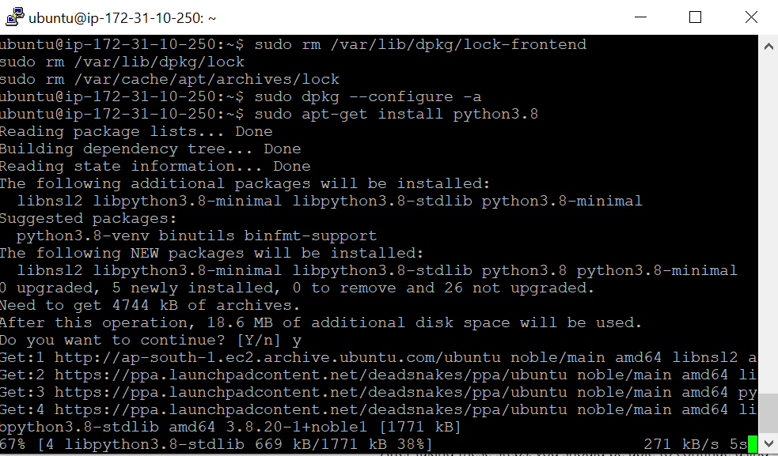

***Getting through the installation process***

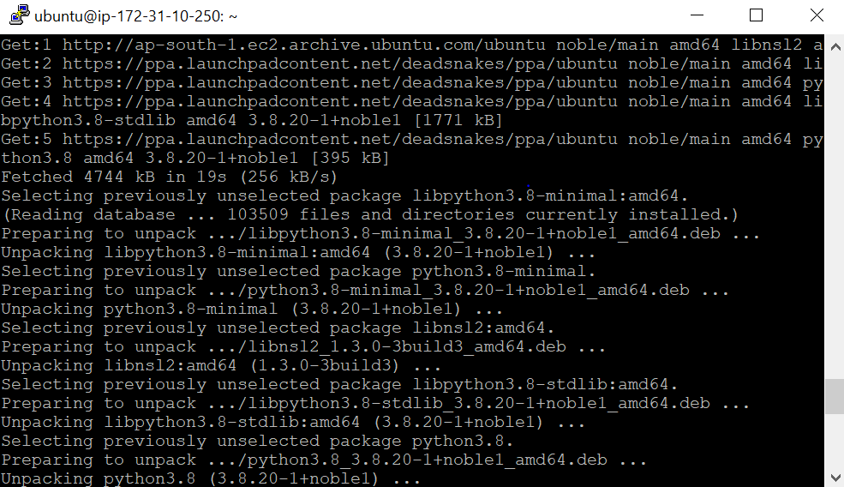

***Finished Installation***

Here, the required installation is completed.

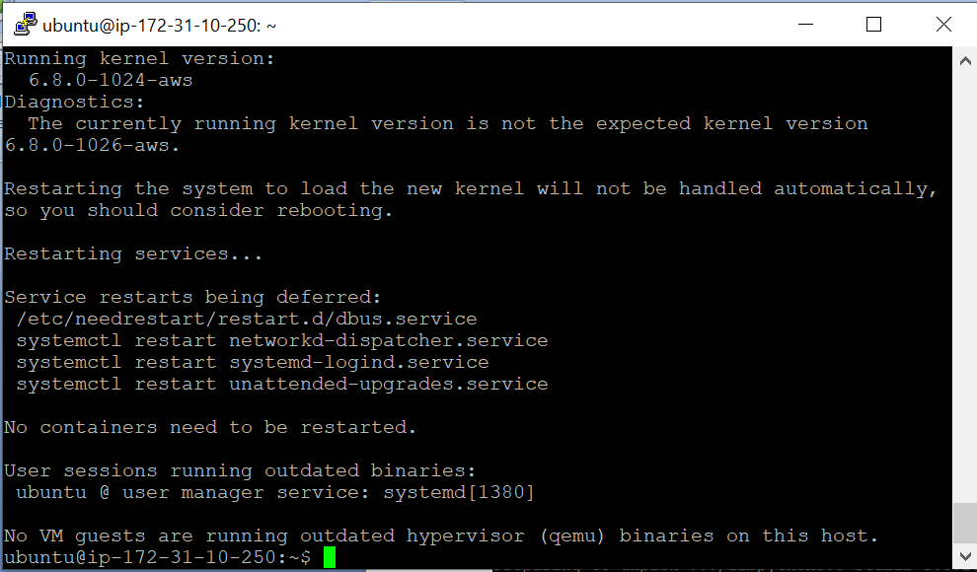

To verify the installation enter the following commands in your Terminal.

python3.8

***Run our First Python Program***

Let’s consider a simple Hello World Program

# Python program to print

# Hello World

print("Hello World")

**OUTPUT:**

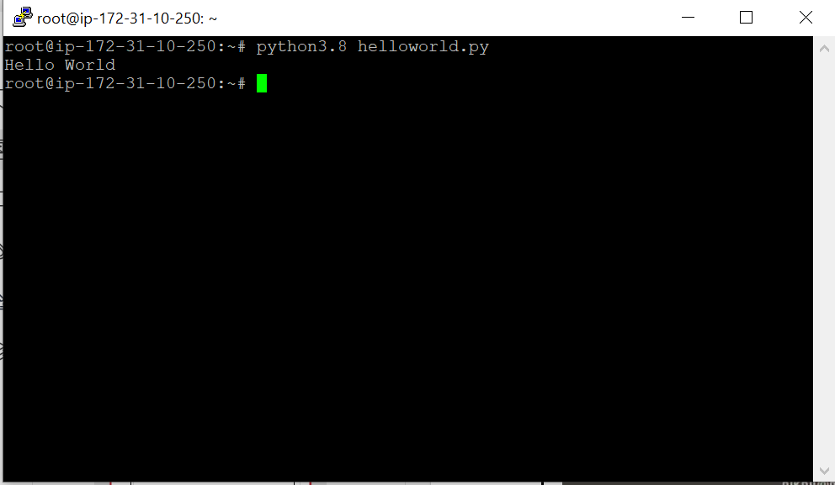

**b)Python 3 on Windows**

Follow the instructions given in the URL

https://docs.python.org/3/using/windows.html(Please remember that Windows

installation of Python is harder!)

The installation requires downloading the official Python *.exe* installer and running it on your

system. The sections below will explain several options and details during the installation

process.

***Step 1: Select Python Version***

Deciding on a version depends on what you want to do in Python. The two major versions are

Python 2 and Python 3. Choosing one over the other might be better depending on your project

details. If there are no constraints, choose whichever one you prefer.

**We recommend Python 3**, as Python 2 reached its end of life in 2020. Download Python 2 only

if you work with legacy scripts and older projects. Also, choose a stable release over the newest

since the newest release may have bugs and issues.

**Step 2: Download Python Executable Installer**

Start by downloading the Python executable installer for Windows:

1. Open a web browser and navigate to the Downloads for Windows section of the official

Python website.

1. Locate the desired Python version.

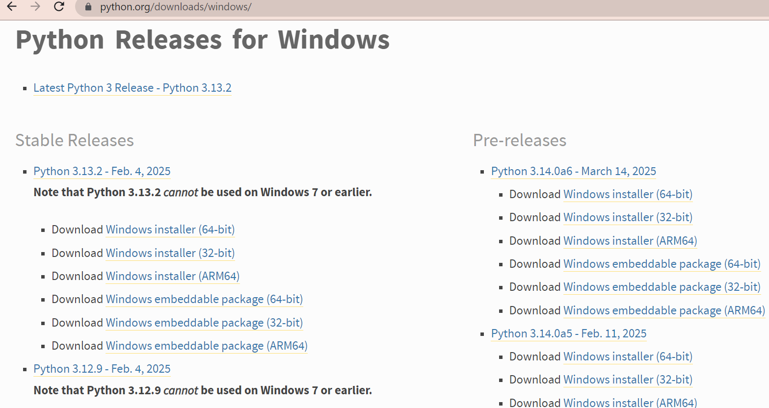

3. Click the link to download the file. Choose either the Windows 32-bit or 64-bit installer.

The download is approximately 25MB.

**Step 3: Run Executable Installer**

The steps below guide you through the installation process:

1. Run the downloaded **Python Installer**
2. The installation window shows two checkboxes:

  **Admin privileges**. The parameter controls whether to install Python for the current or all

system users. This option allows you to change the installation folder for Python.

 Add Python to PATH. The second option places the executable in the PATH variable

after installation. You can also add Python to the PATH environment variable manually

later.

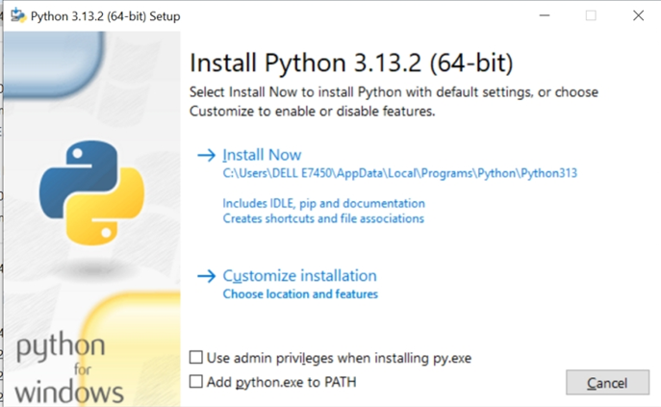

For the most straightforward installation, we recommend ticking both checkboxes.

3. Select the **Install Now** option for the recommended installation (in that case, skip the next two

steps).

To adjust the default installation options, choose **Customize installation** instead and proceed to

the following step.

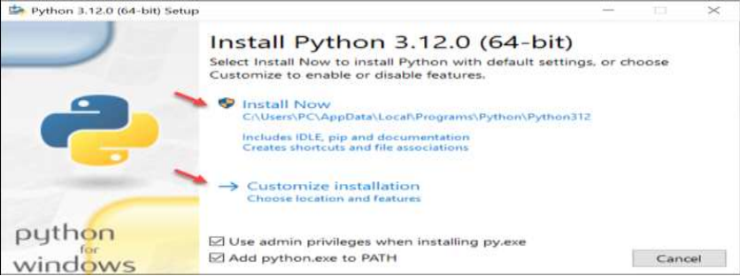

The default installation installs Python

to *C:\Users\[user]\AppData\Local\Programs\Python\Python[version]* for the current user. It

includes IDLE (the default Python editor), the PIP package manager, and additional

documentation. The installer also creates necessary shortcuts and file associations.

Customizing the installation allows changing these installation options and parameters.

4. Choose the optional installation features. Python works without these features, but adding

them improves the program's usability

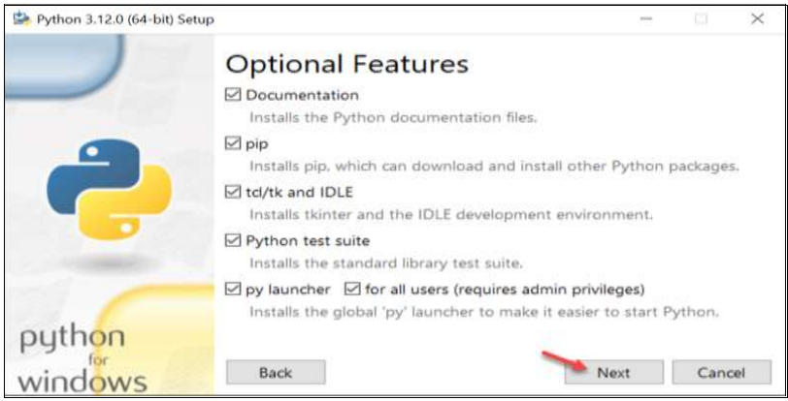

Click **Next** to proceed to the Advanced Options screen.

5. The second part of customizing the installation includes advanced options.

Choose whether to install Python for all users. The option changes the install location

to *C:\Program Files\Python[version]*. If selecting the location manually, a common choice

is *C:\Python[version]* because it avoids spaces in the path, and all users can access it. Due to

administrative rights, both paths may cause issues during package installation.

Other advanced options include creating shortcuts, file associations, and adding Python to

PATH.

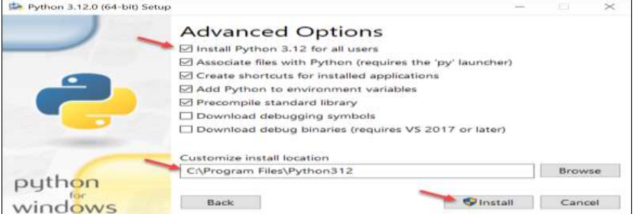

After picking the appropriate options, click **Install** to start the installation.

6. Select whether to disable the path length limit. Choosing this option will allow Python to

bypass the 260-character **MAX_PATH** limit.

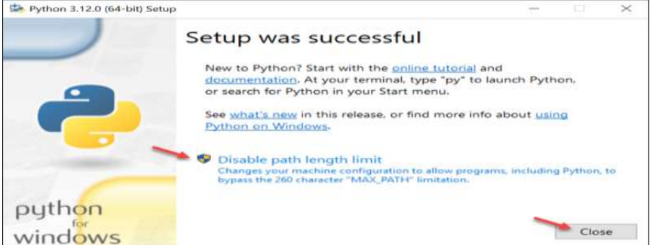

The option will not affect any other system settings, and disabling it resolves potential name

length issues. We recommend selecting the option and closing the setup.

**Step 4: Add Python to Path (Optional*)***

If the Python installer does not include the **Add Python to PATH** checkbox or you have not

selected that option, continue in this step. Otherwise, skip to the next step.

Adding the Python path to the PATH variable alleviates the need to use the full path to access the

Python program in the command line. It instructs Windows to review all the folders added to the

PATH environment variable and to look for the *python.exe* program in those folders.

To add Python to PATH, do the following:

1. In the **Start** menu, search for **Environment Variables** and press **Enter**.

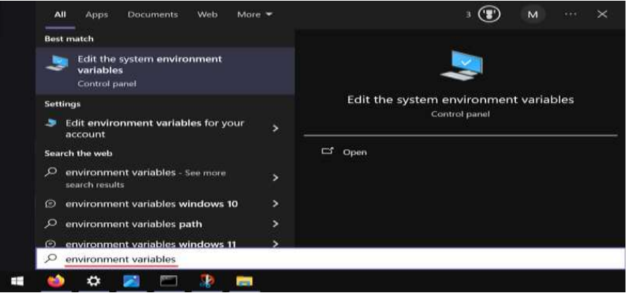

2. Click **Environment Variables** to open the overview screen.

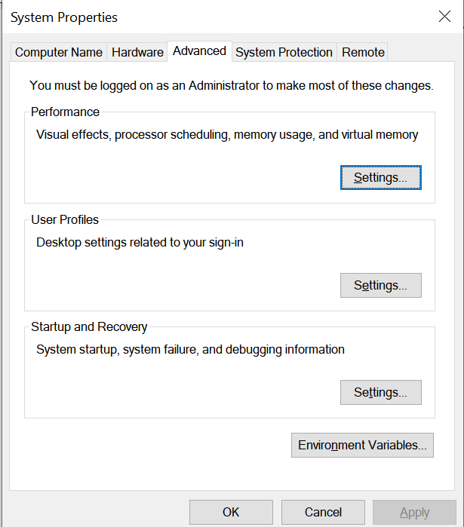

1. Double-click **Path** on the list to edit it.

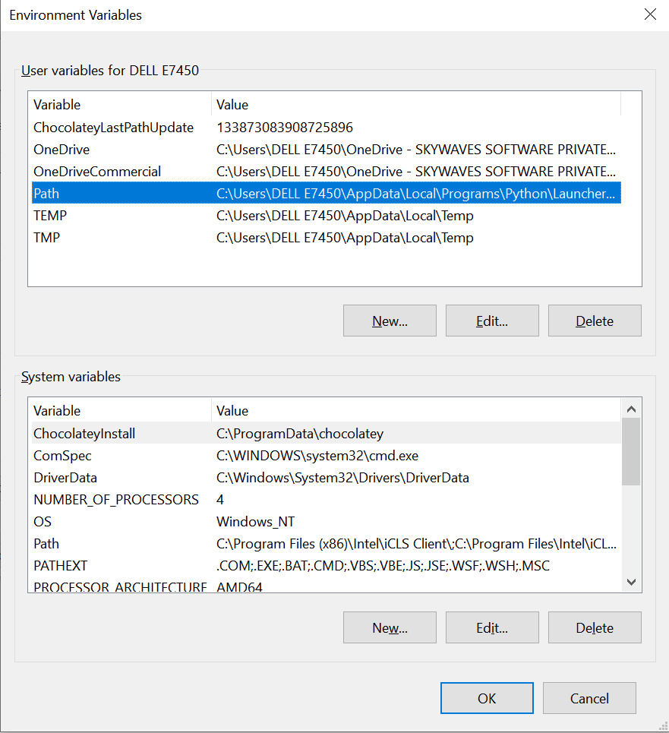

Alternatively, select the variable and click the **Edit** button.

4. Double-click the first empty field and paste the Python installation folder path.

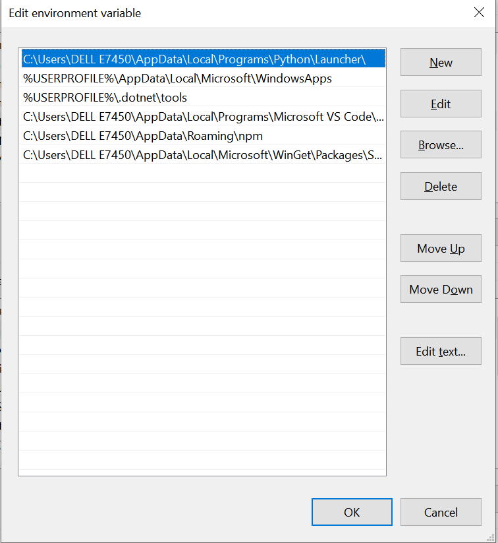

Alternatively, click the **New** button instead and paste the path.

3. Click **OK** to save the changes. If the command prompt is open, restart it for the

following step.

**c)pip3 on Windows and Linux**

Install the Python package installer by following the instructions given in the

URLhttps://www.activestate.com/resources/quick-reads/how-to-install-and

use-pip3/

Check if pip is already installed by running the following on the command line:

Pip - -version

Or

Pip -v

If pip is installed, you’ll see something similar to the following output:

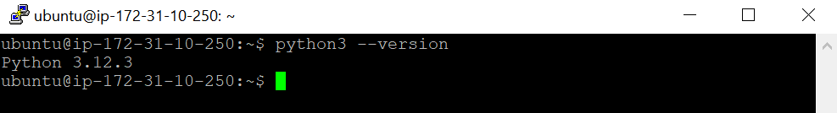

You should see something like the following if Python is installed:

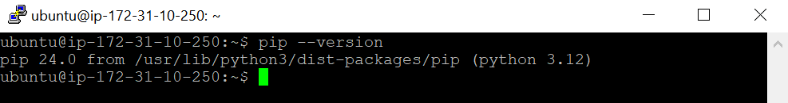

If you do not have a version of Python installed, you can quickly download and install a recent

version of ActivePython.

Adding PIP to Windows Environment Variables

One of the most common problems with running Python tools like pip is the “not on PATH”

error. This means that Python cannot find the tool you’re trying to run in your current directory.

In most cases, you’ll need to navigate to the directory in which the tool is installed before you

can run the command to launch it.

If you’d rather run pip (or other tools) from any location, you’ll need to add the directory in

which it’s installed as a PATH environment variable by doing the following:

1. Open up the **Control Panel** and navigate to **System and Security > System**

2. Click on the **Advanced system settings** link on the left panel

3. Click **Environment Variables**.

4. Under **System Variables**, double-click the variable PATH.

5. Click **New**, and add the directory where pip is installed, e.g. C:Python33Scripts, and

select **OK.**

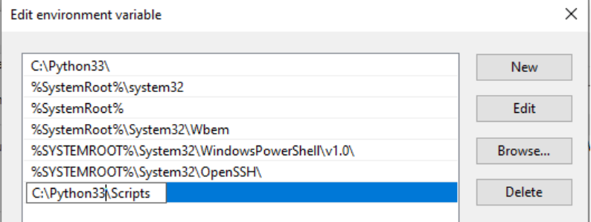

Upgrading Pip on Windows

Pip is a key tool in the Python ecosystem, and as such is updated on a regular basis. Changes can

always be found in the release notes for each version. In order to keep your version of pip up to

date, you can run the following on the command line:

python3 -m pip uninstall pip

This command will uninstall the outdated version of pip first, and then download the most

current iteration.

It’s also possible to downgrade to a previous version of pip, in case a newer version is causing

unexpected compatibility errors. For example, to downgrade to pip v18.0 run the following

command:

sudo apt install python3-pip

**d)Installing numpy and scipy**

You can install any python3 package using the command pip3 install <packagename>

Steps for Installing NumPy

1. Download and Install Python.

 Python should be installed before installing NumPy.

 Download Python from Python's official website according to the operating system. After

installing Python, Numpy is installed using different commands in different operating

systems.

Let's see how NumPy is installed on different operating systems.

Installing Numpy

1. Installing NumPy on Mac Operating System

1. Check if pip3 and python3 are installed correctly by running the following command:

Pythom3 –version

Pip3 –version

2. Install numpy by using the pip command:

Pip3 install numpy

3. Verify installation by typing the following command:

Import mumpy

2. Installing NumPy on Windows Operating System

Steps for installing NumPy on Windows:

1. Install NumPy using the following PIP command in the command prompt terminal:

Pip install numpy

**e)Installing jupyterlab**

Install from pip using the command pip install jupyterlab

**JupyterLab**

Install JupyterLab with pip:

Pip install jupiterlab

**Note**: If you install JupyterLab with conda or mamba, we recommend using the conda-forge

channel.

Once installed, launch JupyterLab with:

Jupiterlab

**WEEK2:**

**2.Introduction to Python3**

**a)Printing your biodata on the screen**

**Program:**

**# Define a function 'personal_details'.**

**def personal_details():**

**# Define variables 'name' and 'age' and assign values to them.**

**name, age = "Shreshta", 19**

**# Define a variable 'address' and assign a value to it.**

**address = "Hyderabad, Telangana, India"**

**# Print the personal details using string formatting.**

**print("Name: {}\nAge: {}\nAddress: {}".format(name, age, address))**

**# Call the 'personal_details' function to display the details.**

**personal_details()**

**Output:**

**Name: Shreshta**

**Age: 19**

**Address: Hyderabad, Telangana, Indiass**